3D Printed Drill Frame: ER8 through ER32
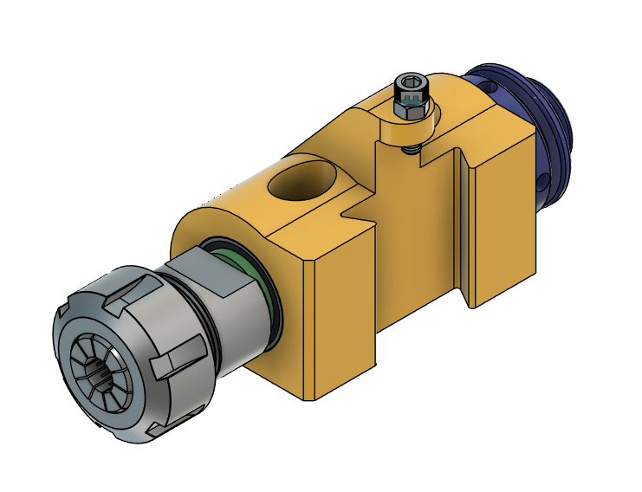

The ER collet extensions should have a shaft length of 100mm. Typical designation looks like this: C20-ER25-100L where C?? is the shaft diameter, ER?? Is the collet size, and ???L is the shaft length. Note: Some vendors list the length as the overall length instead of the shaft length.
32mm OD bearings enable using multiple sizes of ER collet extensions. Bearings with IDs of 12, 20, and 25 millimeters are available as well as ER collet extensions ER8 through ER32 with matching shaft diameters. Bearings with less than 10mm width must have flanges. 10mm width bearings do not need flanges. Bearings should be a light press fit into the housing.
An M5 bolt, nut, and washer are used to adjust the center height on the AXA QCTP.
The bearings may get hot when this is run for the first time. This usually stops after several uses. The elliptical holes in the housing help to cool it. Care should be taken when tightening this in the AXA QCTP.
The centerline of this is designed to match the centerline of an AXA 250-104 boring bar holder.

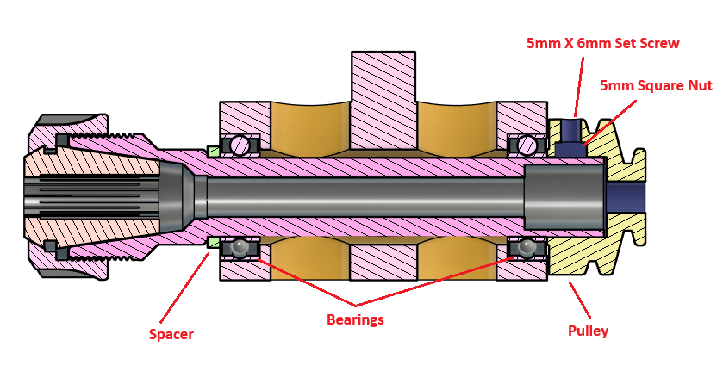
The spacer may or may not be required. It depends on the diameter of the ER head. Some ER collet extensions have a stress relief groove at the base of the head and the diameter of some heads would allow both the inner and outer rings to ride on the head.
The 20mm and 25mm bore pulleys are attached with two M5 x 6mm set screws and 2 M5 square nuts. 12mm bore pulleys just use the M5 set screws in printed threads.
Bearing sizes:
- F6705ZZ 25x32x4mm
- F6804ZZ 20x32x7mm
- 3804 ZZ 20x32x10mm
- 6201ZZ 12x32x10mm

3D Print Settings
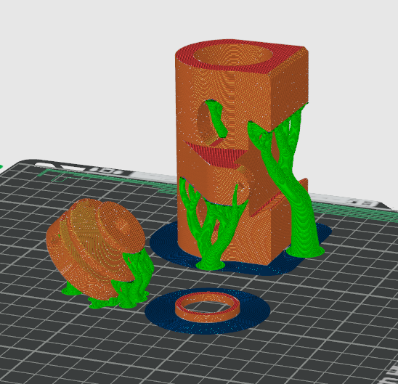

Print the main housing vertically. Printing the pulley at a 45 degree angle allows it to print with fewer supports. If printing flat, the smaller end should be down.
Basic Settings:
- 0.2 Layer height
- 8 Walls
- 40% Infill
- Cubic style infill
- Filament: ABS-GF (Other filaments may work as well.)
Pulley and spacer models for all 3 sizes are on the build plate (ER_DrillFrame_AXA.3mf), Remove the unnecessary ones before printing.
Step files are included for all versions.

